VBA Homework: The VBA of Wall Street

Author: George Alonzo

Due Date: Sept 11, 2021

Below are the required screenshots for each year (tab) of the results on the Multi Year Stock Data workbook.

**2016**

General screen shot:

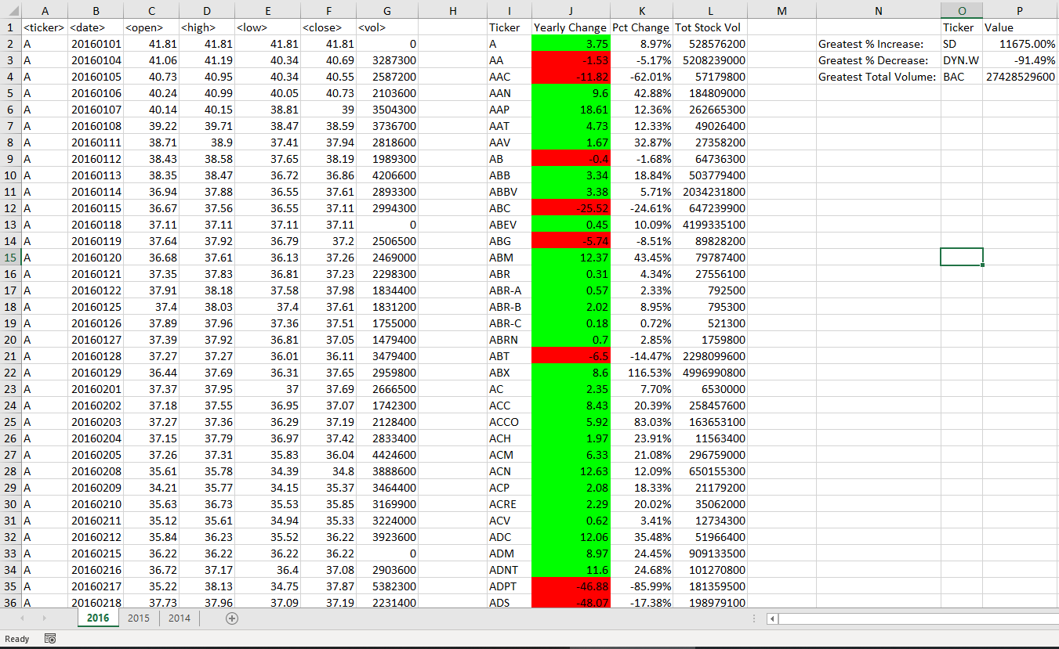

Close-up of summary and ‘greatest’ values:

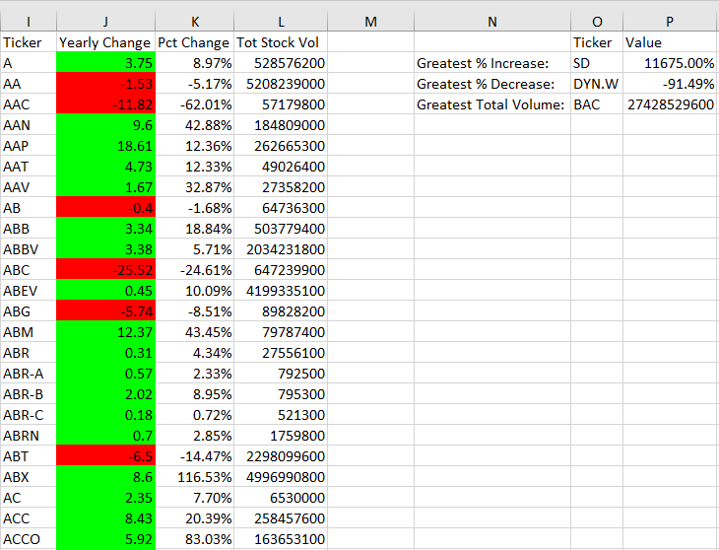

**2015**

General screen shot:

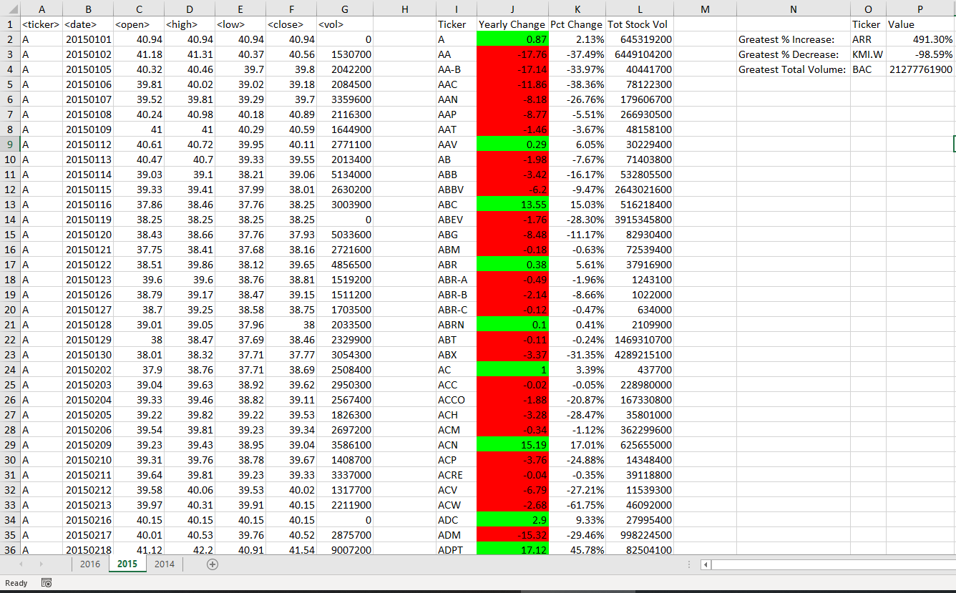

Close-up of summary and ‘greatest’ values:

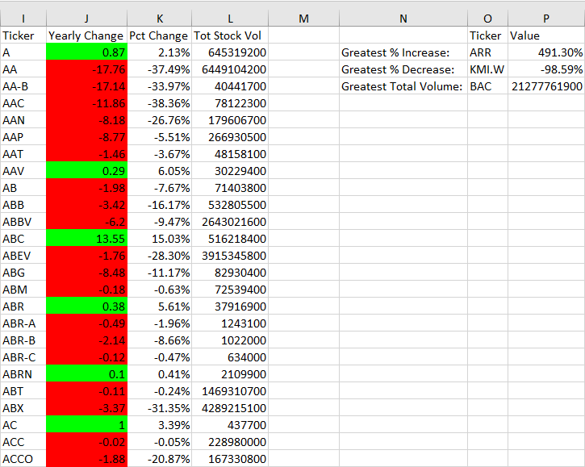

**2014**

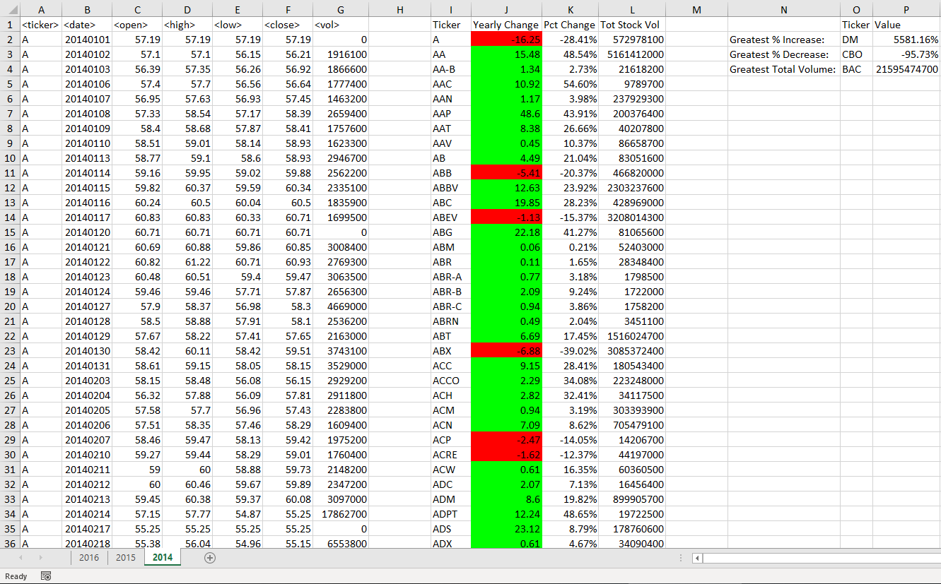

Close-up of summary and ‘greatest’ values:

